1. Write a query which displays Staff Name, Department Code, Department Name, and Salary for all staff who earns more than 20000.

Query:

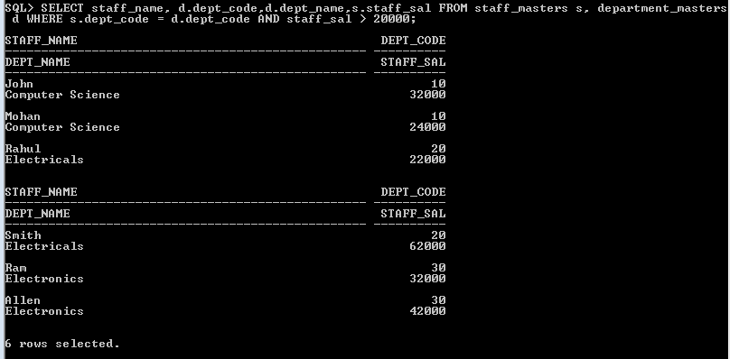

1. Display Staff Code, Staff Name, Department Name, and his manager’s number and name. Label the columns Staff#, Staff, Mgr#, Manager.

Query:

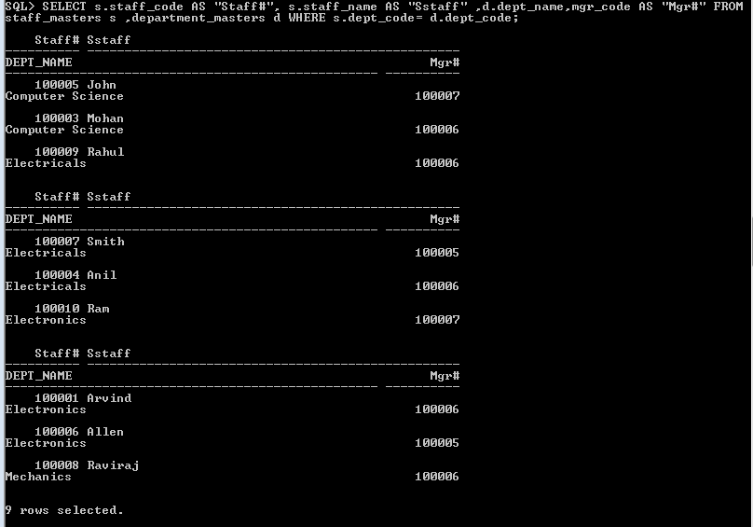

1. Create a query that will display Student Code, Student Name, Book Code, and Book Name for all students whose expected book return date is today.

Query:

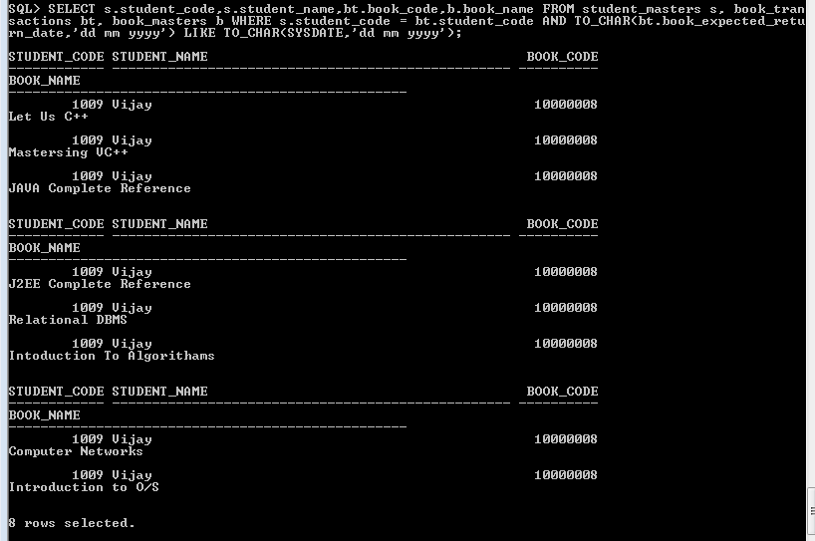

1. Create a query that will display Staff Code, Staff Name, Department Name, Designation name, Book Code, Book Name, and Issue Date for only those staff who have taken any book in last 30 days. . If required, make changes to the table to create such a scenario.

Query:

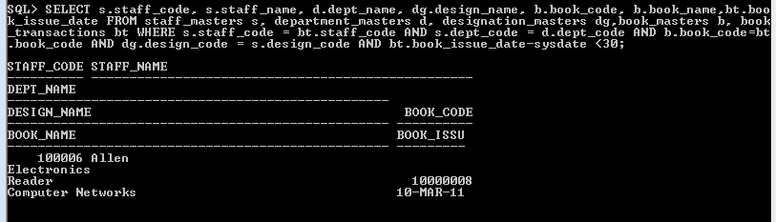

1. Generate a report which contains the following information.

Staff Code, Staff Name, Designation Name, Department, Book Code, Book Name,

Author, Fine For the staff who has not returned the book. Fine will be calculated as Rs. 5 per day.

Fine = 5 \* (No. of days = Current Date – Expected return date). Include records in the table to suit this problem statement.

Query:

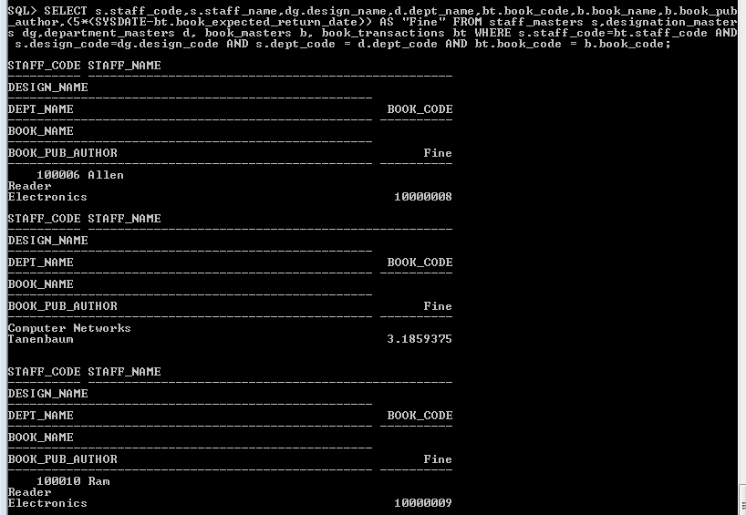

1. List Staff Code, Staff Name, and Salary for those who are getting less than the average salary of organization.

Query:

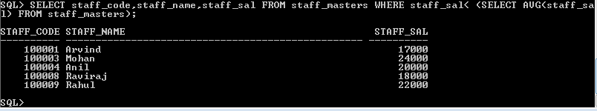

1. Display Author Name, Book Name for those authors who wrote more than one book.

Query:



1. Display Staff Code, Staff Name, and Department Name for those who have taken more than one book.

Query:

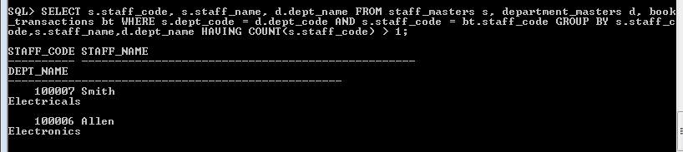

1. Display the Student Code, Student Name, and Department Name for that department in which there are maximum number of student studying.

Query:

1. Display Staff Code, Staff Name, Department Name, and Designation name for those who have joined in last 3 months.

Query:

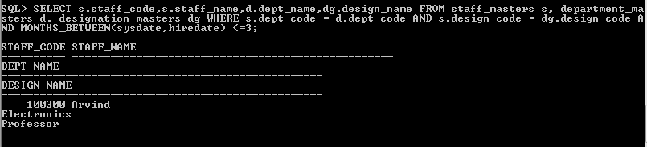

1. Display the Manager Name and the total strength of his/her team.

Query:

1. Display the details of books that have not been returned and expected return date was last Monday. Book name should be displayed in proper case.. Hint: You can change /add records so that the expected return date suits this problem statement.

Query:

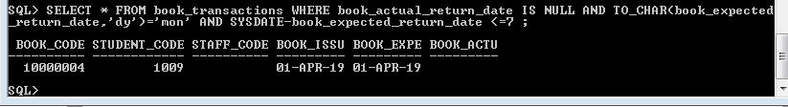

1. Write a query to display number of people in each Department. Output should display Department Code, Department Name and Number of People.

Query: